St. Matthias School

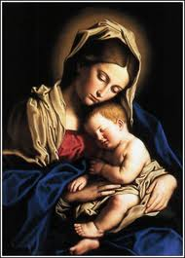

Please join us as St. Matthias School celebrates
Catholic Schools Week 2015

FAMILY MASS followed by OPEN HOUSE
Sunday, January 25th
10:00am-12:30pm
Mass/Student Expo/School Tours/Book Fair
Refreshments will be served
Registration Information available in the school office

SPECIAL PERSONS’ DAY
Tuesday, January 27th

9:00am-10:15am in the gym
Entertainment by grades Pre-K to 4th Grade
Refreshments will be served
This day is for parents, relatives and friends.

OPEN HOUSE for NEW & Current Families

Wednesday, January 28th 9:00AM- 11:00AM
Book Fair

over>>>>>

WINTER CONCERT
Wednesday, January 28th
7:00pm
Children’s Choir and St. Matthias Experienced Band
ALL WELCOME!

STUDENT APPRECIATION DAY
Thursday, January 29th
For School Children only
Free Dress Down(sneakers or school shoes only)
Free Pizza for students & faculty.

TEACHER APPRECIATION DAY
Friday, January 30th
12:00 dismissal for Faculty Appreciation Luncheon sponsored by the St. Matthias Educational Foundation.

* * * * *

SAINT MATTHIAS SCHOOL CELEBRATES
100+ YEARS OF QUALITY, CATHOLIC EDUCATION SERVING THE FAMILIES OF QUEENS AND BROOKLYN.

A SPECIAL THANK YOU TO ALL WHO WILL HELP TO MAKE THIS A WEEK OF CELEBRATION!

