Mary, Holy Mother of God – St. Matthias Educational Foundation Scholarship Contest
Contest dates: January 25 to March 1, 2015
The Blessed Virgin Mother provides us with a wonderful example of holiness and faithfulness. This year The St. Matthias Educational Foundation Essay Contest focuses on our school theme “The Blessed Virgin Mary”. We are asking families to consider Mary’s role in our spiritual journey and how her story relates to our lives.
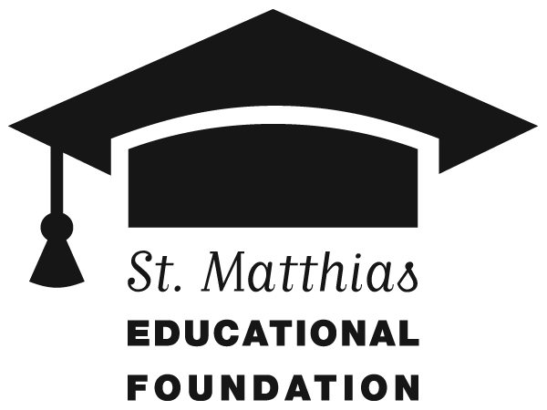
Submissions must be handwritten. Essays will be judged on content and form. Student essays for grades 3 to 8 must be composed and written by the student. Each entry must include the form below. Prizes: Six Scholarships of $500 each will be awarded to students registering for the 2015-2016 school year at St. Matthias School. 3 scholarships will be awarded, one in each grade category, to current school families. 3 additional scholarships will be awarded, one in each grade category, to the winning essays of students new to the school in 2015-2016. Scholarship checks will be written directly to the school and applied to tuition for 2015-2016. Scholarship awards will be announced on March 22, 2015 at the 10 AM Mass. (Students need not be present to win.)
Grade Categories: (The named grade is the grade for 2015-2016.)
Pre-K to Two – We learn about Mary’s love through the Bible and her prayers. Students are asked to draw a picture of Mary on an 8 ½ x 11 paper. Please allow the student to do their own artwork. All representations done by children are acceptable. (Artwork done by adults disqualifies the entry.) Parents are asked to write a short prayer with their child to Mary.
Three to Five – Students are asked to write a short essay of 75-100 words answering the question - How is Mary like your own mother (or an important woman in your life)? How does Mary help you to grow in your love of Jesus?
Six to Eight – Students are asked to write a short essay of 100-150 words answering the question – How can I show courage and faith like Mary as I face the challenges in my everyday life? Give at least two examples.
-----------------------------------------------------------------------------------------------------------------------
St. Matthias Educational Foundation Scholarship Contest – Mary, Holy Mother of God
Student Name:__________________________________ Grade for 2015/16 _____
Address:______________________________________________________________
Phone Number:_____________________ Parent Signature: __________________________________
Circle One: Current Student New Student

